Akamai Cache Clear
Open this URL (https://control.akamai.com/apps/fast-purge) and enter your credentials for login akamai control center
After login you can see this page
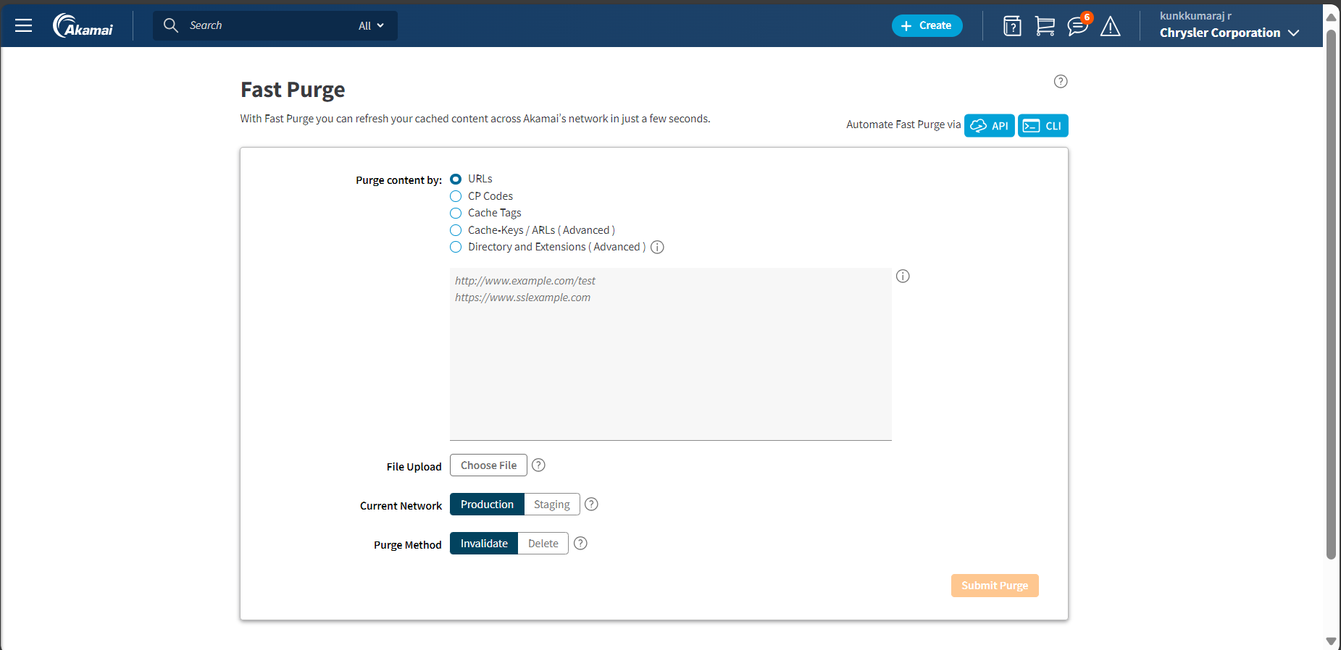
You have a multiple option to clear a cache so you can use URLs, CP Codes, Cache Tags, ache Keys and Directory and Extensions
In the text box you have to enter the URL which you need to clear cache and next you have to select Current network this will be a UAT URL or Production URL if it’s UAT URL you have to select Staging if it’s production URL you have to select Production
Next you have a purge method you have to select delete for clear cache and click Submit Purge for clear cache and it will take 2 to 3 min to clear the cache.
Click here to clear cache.
Here you must select URL type its UAT or Production
Here you have to select delete
Here you have to give URL which you want to clear cache.
Here you have to select which content you have for cache clear

